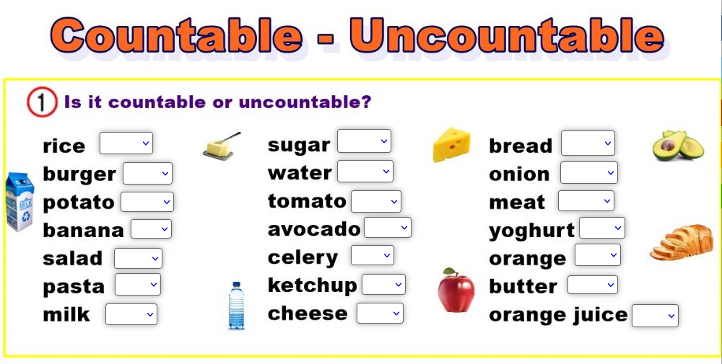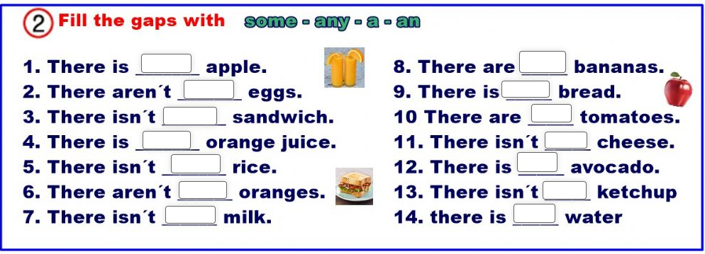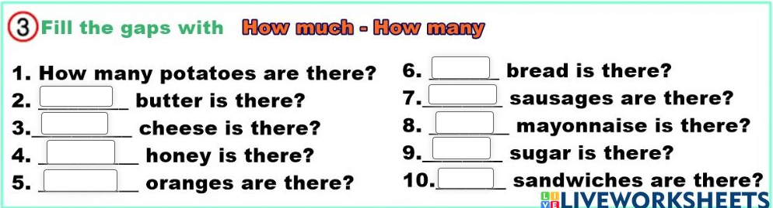

**COUNTABLE** **NOUNS** **UNCOUNTABLE** **NOUNS**

- **a/an** - **some (**can’t have **~~a/an~~)**

- have **Plural** - **NO Plural**

- **a lot of (+)/many (-,?)/How many?** - **a lot of(+) / much(-,?)/ How much?**



**COUNTABLE** **NOUNS** **UNCOUNTABLE** **NOUNS**

- **a/an** - **some (**can’t have **~~a/an~~)**

- have **Plural** - **NO Plural**

- **a lot of (+)/many (-,?)/How many?** - **a lot of(+) / much(-,?)/ How much?**